CHILDREN AT RISK NETWORK NEPAL
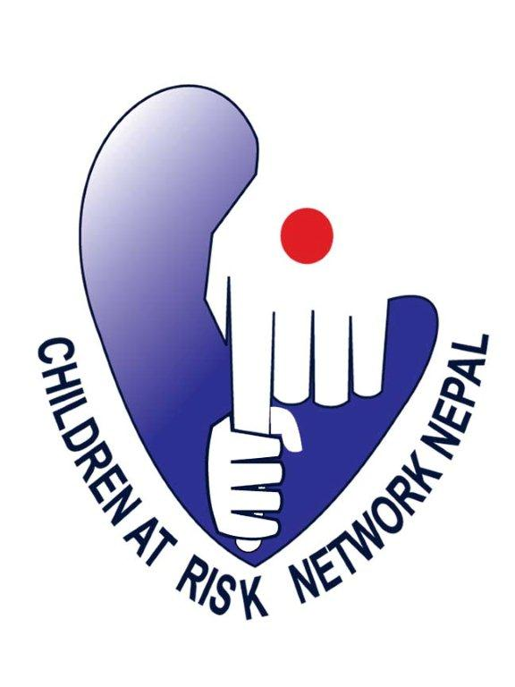

Recent Passport size Photo

(CarNetNepal)

Application Form

(Project Officer- Sindhupalchowk)

- Personal Information
Name |  | Sex
Date of Birth (AD) |  | Marital Status
Date of Birth (BS) |  | Nationality
Permanent Address |  | Temporary Address
Email ID |  | Telephone/ Mobile No.
Father’s Name |  | Qualification

2. Work Experience
Employer | Job Title | Main Responsibilities | Dates of Employment | Reason for Leaving

3. Language Skills
Language | Level of spoken competence  (e.g. basic, intermediate, fluent) | Level of written competence  (e.g. basic, intermediate, advanced)

4. Computer Skills
Please describe your level of computer literacy, stating applications of which you can use competently.

5. Other Relevant Training /Information
5.1. Please detail other relevant training or information which you feel may support your application.
5.2. Please state monthly salary that you expect for the post you are applying for. (Its compulsory to fill this space)
NRs.

6. References
Title | Name | Address (include email and telephone number if appropriate)

7. CarNetNepal's General Questions:
7.1. What do you understand by 'Children at Risk'?

7.2. What is the position that you have applied for and what do you understand by the position?

7.3. Describe a time when you have shown a great flexibility in your job, and describe the affect you had.

7.4. Why are you attracted to work in CarNetNepal?

7.5. What field experience do you have for a child protection officer position?

7.6.What have you done in the last twelve months to improve safeguarding of children in the workplace?

7.7. What is your strength and how do your strengths contribute to this position?

7.8. What is your weakness?

7.9. If you are selected to work in CarNetNepal, what would be your commitment?

7.10. If you have to work over time (e.g. sometime more than the office hour, holidays etc.), how would you feel? Would you be able to travel outside of the Kathmandu valley frequently?

Signature: Date:

