CHILDREN AT RISK NETWORK NEPAL
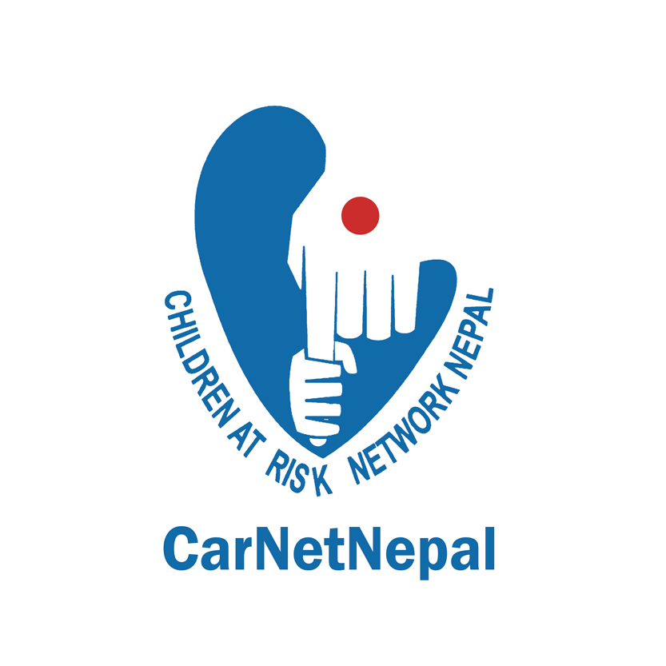

Recent Passport size Photo

(CarNetNepal)

Application Form

(Paid Volunteer - Jugal RM, Sindhupalchowk)

- Personal Information
Name |  | Sex
Date of Birth (AD) |  | Marital Status
Date of Birth (BS) |  | Nationality
Permanent Address |  | Temporary Address
Email ID |  | Telephone/ Mobile No.
Father’s Name |  | Qualification

2. Work Experience
Employer | Job Title | Main Responsibilities | Dates of Employment | Reason for Leaving

3. Language Skills
Language | Level of spoken competence  (e.g. basic, intermediate, fluent) | Level of written competence  (e.g. basic, intermediate, advanced)

4. Computer Skills
Please describe your level of computer literacy, stating applications of which you can use competently.

5. Other Relevant Training /Information
5.1. Please detail other relevant training or information which you feel may support your application.
5.2. Please state monthly salary that you expect for the post you are applying for. (Its compulsory to fill this space)
NRs.

6. References
Title | Name | Address (include email and telephone number if appropriate)

7. CarNetNepal's General Questions:
7.1. What do you understand by 'Children at Risk'? And the post that you have applied?

7.2. Describe a time when you have shown a great flexibility in your job, and describe the affect you had.

7.3. Why are you attracted to work in CarNetNepal?

7.4. Please explain briefly about the situation of children in Nepal?

7.5. What are your greatest strengths and how do your strengths contribute to this position?

7.6. What are the areas of improvement in your personnel being? How do you think that you would improve them in the near future?

7.7. If you are selected to work in CarNetNepal, what would be your commitment?

7.8. If you have to work over time (e.g. sometime more than the office hour, holidays etc.), how would you feel? Would you be able to travel outside of the working district as well as staying in the Municipality?

7.9. How do you see the aid agencies and the poor people in Nepal? Please mention your responsibilities in the midst of the aid agencies and the government bodies in the development of Nepal. (Answer in at least 120 words)

Signature: Date:

